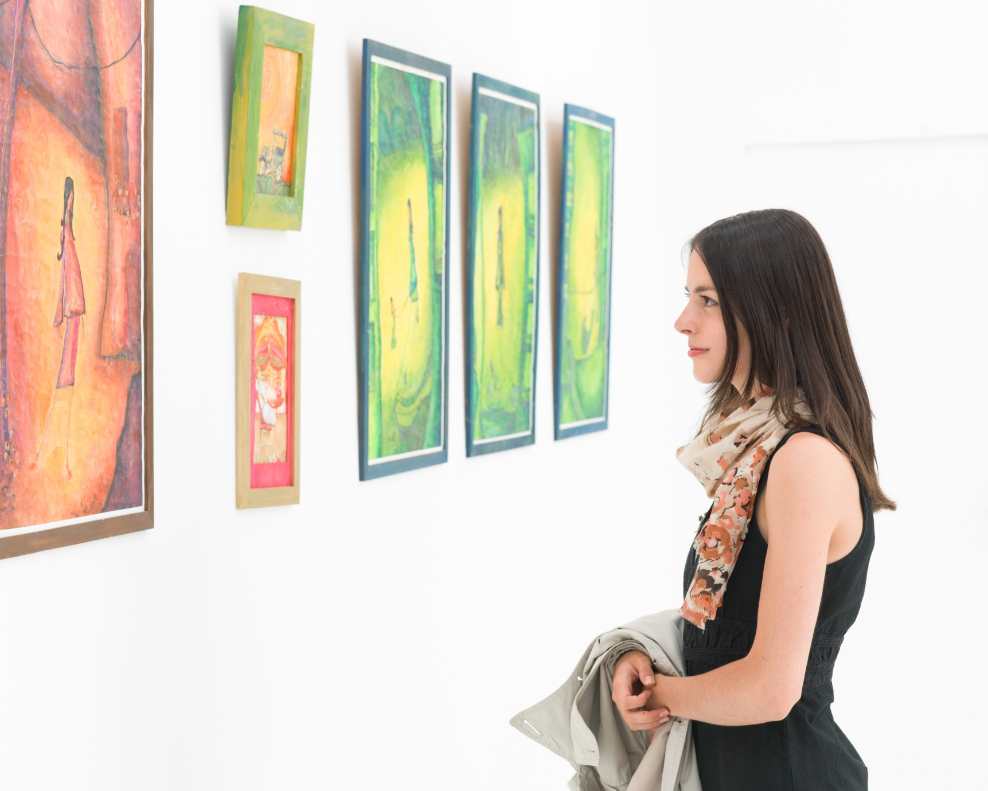 

Lancefield

Mad Gallery: 19 High Street, Lancefield.

*Contemporary and leading edge fine art*

Phone: 5429 1432

Open: 7 days

[www.madgallery.com.au](http://www.madgallery.com.au)

**Art Galleries**

in the Macedon Ranges

All information is correct at the time of printing. Disclaimer – The publishers are not liable for any injury, damage or loss arising from the use of any service or product featured in this publication.

Untitled-1.png

**MACEDON RANGES NATURALLY COOL**



**This brochure is one of a series promoting the**

**Macedon Ranges.**

**To view the full range of brochures please speak to a volunteer at the Visitor Information Centres or call 1800 244 711.**

**FEBRUARY 2019**

C:\Users\C-15\Desktop\Untitled-1.png

The Golden Dog Gallery: 11 High Street, Kyneton.

Phone: 0432 060 317

Open: Thursday/ Friday/ Saturday

Woodend

Fox in the Chamber: 90 High Street, Woodend.

*Showcasing local art in a coffee house setting*

Phone: 0432 162 645

Open: Wednesday - Sunday

[www.thechamber.net.au](http://www.thechamber.net.au)

Woodend Art Walk

*Artwork from the Woodend Art Group may be viewed over lunch, coffee & cake in four cafes in Woodend. All works are for sale and a brochure is available at the*

*Macedon Ranges Visitor Information Centres or in the cafes.*

[www.woodendartgroup.org.au](http://www.woodendartgroup.org.au)

Mt Macedon

The Gallery - Macedon Ranges Arts Collective: 684 Mount Macedon Road, Mount Macedon.

*Local Arts & Crafts*

Phone: 5426 3322

Open: Friday-Tuesday

[www.thegallerymtmacedon.com.au](http://www.thegallerymtmacedon.com.au)

Riddells Creek

Dromkeen: 1012 Gisborne- Kilmore Road

*Historic property, tearooms, gallery of illustrations from children’s literature*

Phone: 5428 6799

Open: Thursday to Saturday

For more information, please contact the Visitor Information Centres on 1800 244 711

Open 7 days, 9am-5pm. Email vic@mrsc.vic.gov.au, or visit www.visitmacedonranges.com

**Kyneton Visitor Information Centre**

High Street, Kyneton

**Woodend Visitor Information Centre**

High Street, Woodend

Malmsbury

**Tin Shed Arts**: 75 Mollison Street, Malmsbury.

*Showcasing various artwork by local artists*

Phone: 5423 2144

Open: Friday – Monday

[www.malmsburybakeryandgallery.com.au](http://www.malmsburybakeryandgallery.com.au)

Gisborne

Artists Realm: 52 Hamilton Street, Gisborne.

*Picture framing and digital ink jet printing*

Phone: 5428 3614

Open: 7 days

[www.artistsrealm.com.au](http://www.artistsrealm.com.au/)

**Glenrowan Gallery**: 4 Charles Court, Gisborne.

*Australian wildlife, Australian realism, impressionism*

Phone: 5428 3383

Open: Saturday & Sunday

[www.gerasimon.com.au](http://www.gerasimon.com.au)

Kyneton

Art on Piper- The Artists’ Gallery

44 Piper Street, Kyneton

Phone: 0411 530 015, 0407 887 497, 0408 351 137

[www.artonpiper.com](http://www.artonpiper.com)

Benita Murray

*Art works for sale, workshop & classes*

Phone: 0409 539 062

Open: by appointment only

Gallery 40; 9 Piper Street, Kyneton.

Photography, handmade cards, glass objects for sale

Phone: 0438 356 025  
www.gallery40.com.au

Advertised exhibitions or visits by appointment

John Lloyd Gallery: 48 Piper Street, Kyneton.

Phone: 5422 7053

[www.johnlloydgallery.com.au](http://www.johnlloydgallery.com.au)  
Open: Saturday and Sunday 10.00am – 4.00pm (weekdays by appointment)

Lauriston Press: 37B Piper Street, Kyneton.

*Drawings, etchings, sculpture & open working studio*

Phone: 5422 1710 or 0423 630 783

[www.lauristonpress.com.au](http://www.lauristonpress.com.au)

Open: Thursday - Monday

Stockroom: 98 Piper Street, Kyneton.

Phone: 5422 3215

Open: Monday - Saturday

Kyneton Mosaic Walk & Black Saturday Memorial

*Various locations around Kyneton*

Maps available at the Macedon Ranges Visitor Information Centres

The Old Auction House: 52-56 Mollison Street, Kyneton.

Phone: 5422 2047

[www.theoldauctionhouse.com.au](http://www.theoldauctionhouse.com.au)

Open: 7 days